
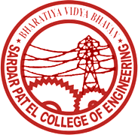
BharatiyaVidyaBhavan’s
Sardar Patel College of Engineering
(A Government Aided Autonomous Institute)
Munshi Nagar, Andheri (West), Mumbai – 400058

Department of Mechanical Engineering
PhD (Mechanical Engg) Programme

Annual/Bi-annual/Topic Approval Seminar
Date:
ATTENDANCE SHEET
Sr. No. | Name of the Student | Signature
1
2
3
4
5

Name and Signature of Research Guides-Convener | 1.  2.  3.
Name and Signature of Subject Experts | 1.  2.  3.
Head of the Department

